Exploratory Data Analysis (EDA) on Wine Quality Dataset

Introduction:
Wine quality analysis is an important task in the food and beverage industry. The quality of wine depends on various physicochemical properties such as acidity, alcohol content, sulphates, and pH. This project focuses on performing Exploratory Data Analysis (EDA) on the Red Wine Quality Dataset to understand the structure of the data, identify patterns, detect outliers, and study the relationship between features and wine quality.
The dataset contains several numerical features and one target variable quality, which represents the quality score of wine rated by experts.

Objective of the Project:
The main objectives of this EDA project are:
- To understand the structure and characteristics of the wine quality dataset
- To check for missing values and duplicate records
- To analyse the distribution of each feature
- To identify outliers using box plots
- To study relationships between features using correlation and heatmap
- To derive meaningful insights that affect wine quality

Attribute Information:
Input variables (based on physicochemical tests):
- 1 - fixed acidity
- 2 - volatile acidity
- 3 - citric acid
- 4 - residual sugar
- 5 - chlorides
- 6 - free sulfur dioxide
- 7 - total sulfur dioxide
- 8 - density
- 9 - pH
- 10 - sulphates
- 11 - alcohol
Output variable (based on sensory data):
- 12 - quality (score between 0 and 10)

Observation from the descriptive summary:
Based on the minimum and maximum values of the quality column, the wine dataset does not contain extremely high-quality wines (like 9 or 10) and also does not include extremely poor-quality wines (like 1 or 2). The quality values mostly lie between 3 and 8, indicating that the dataset represents average to moderate-quality wines.

MULTIVARIATE
Observation from the heatmap:
Based on the correlation analysis, none of the features show a strong relationship with the target variable (quality). The relationships observed are only weak to moderate. Alcohol (+0.48) and volatile acidity (–0.40) show moderate correlation with quality, while all other features have weak or very weak correlations. Therefore, wine quality cannot be explained by any single feature; it is influenced by multiple factors with small contributions.
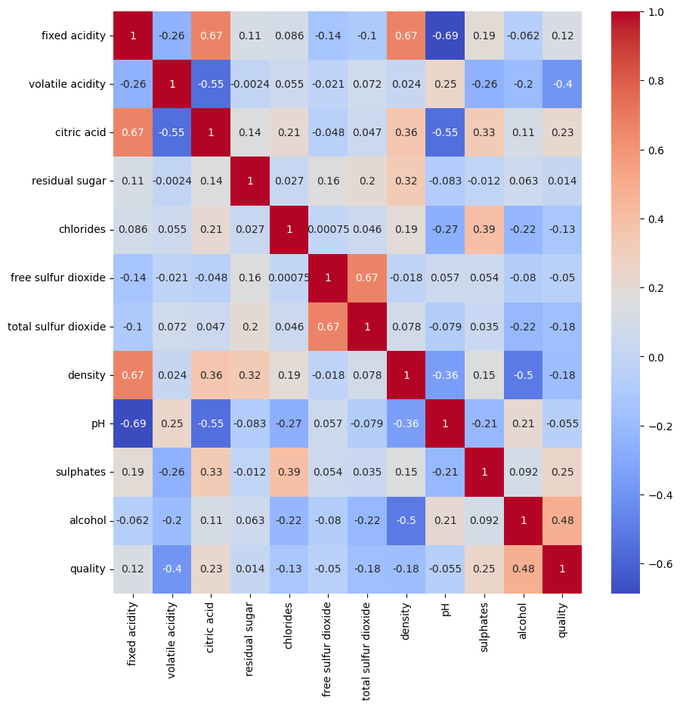
Observation from the pairplot:
A pairplot was used to visually inspect pairwise relationships among numerical features and the target variable. Most relationships appear weak to moderate, with no strong linear dependency

UNIVARIATE
Observation from the barplot:
It is an imbalanced dataset The wine quality dataset is imbalanced, as the majority of observations belong to quality classes 5 and 6, while very few samples are present in the lower (3, 4) and higher (7, 8) quality categories.
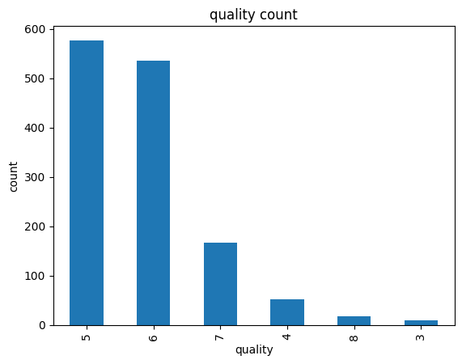

Observation from the histplot:
observation of fixed acidity
The fixed acidity feature shows a right-skewed distribution, with most values concentrated between 6 and 9. A small number of wines exhibit high fixed acidity levels, resulting in a long right tail. This indicates that extremely high acidity wines are relatively uncommon in the dataset.
observation of volatile acidity
The distribution of volatile acidity shows that most wines fall within a moderate range (approximately 0.3 to 0.8). Extremely low and extremely high volatile acidity values are rare. The distribution is right-skewed, indicating the presence of a few wines with unusually high volatile acidity.

observation of residual sugar
The distribution of residual sugar is right-skewed, with most wines having low residual sugar values concentrated around 1.5 - 2.5. A few wines exhibit very high residual sugar values, indicating the presence of outliers. Residual sugar shows a very weak correlation with wine quality but has a positive relationship with density. Higher density is slightly associated with lower wine quality.

observation of citric acid
The distribution of citric acid shows that most wines have low to moderate citric acid values, primarily concentrated between 0.0 and 0.5. Higher citric acid values above 0.6 are rare, indicating a right-skewed distribution with a few outliers.

Observation of chlorides
The distribution of chlorides shows that most wines have low chloride levels, concentrated around 0.04 to 0.10. The distribution is right-skewed with a few wines exhibiting unusually high chloride values, indicating the presence of outliers. Higher chloride levels show a slight negative association with wine quality.

Observation of free sulfur dioxide
The distribution of free sulfur dioxide is right-skewed, with most wines having low to moderate sulfur dioxide levels, concentrated between approximately 5 and 25. A small number of wines exhibit unusually high values, indicating the presence of potential outliers.

Observation of density
The distribution of density is approximately normal, with most wines having moderate density values. Very few wines exhibit extremely low or high density. The distribution appears nearly symmetric with a slight right skew, and no significant outliers are observed.

Observation of ph value
The pH distribution shows that most wines have moderate pH values around 3.2–3.4. Very few wines exhibit extremely low or high pH levels. The distribution is approximately normal with a slight right skew, and no strong outliers are clearly visible.

observation of quality
The wine quality distribution is discrete and imbalanced, dominated by medium-quality wines (ratings 5 and 6), with very few low- and high-quality samples.

Observation of alcohol
The alcohol feature shows a right-skewed distribution, indicating that most wine samples have alcohol content between 9% and 11%. Higher alcohol values are less frequent, resulting in a long right tail. This suggests that wines with very high alcohol content are relatively rare in the dataset.
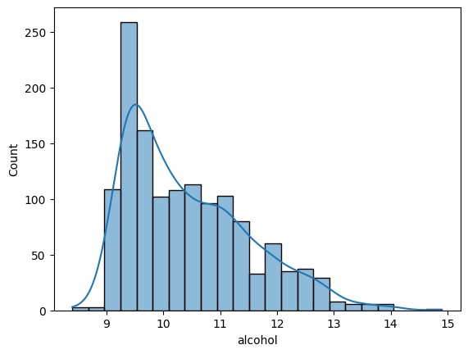

Observation from the boxplot
Most wines have moderate fixed acidity, while a small number of wines exhibit unusually high acidity values.

BIVARIATE
Observation from the boxplot
Moderate quality wines dominate the dataset → most wines are 5 or 6 in quality.
High alcohol outliers exist even in these moderate-quality wines → alcohol alone does not guarantee high quality.
Outliers tell us about variability → Some moderate-quality wines have unusually high alcohol, but their quality is still moderate.
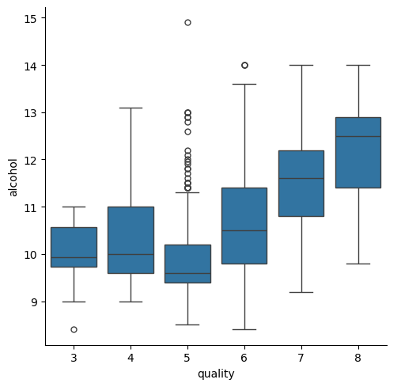

Observation from the scatterplot between alcohol and volatile acidity
The scatter plot shows a negative relationship between alcohol and volatile acidity. Low-quality wines are characterized by higher volatile acidity and lower alcohol content, while high-quality wines tend to have higher alcohol and lower volatile acidity. Most wines in the dataset fall under medium quality (5 and 6), indicating that moderate alcohol and acidity levels dominate the dataset.

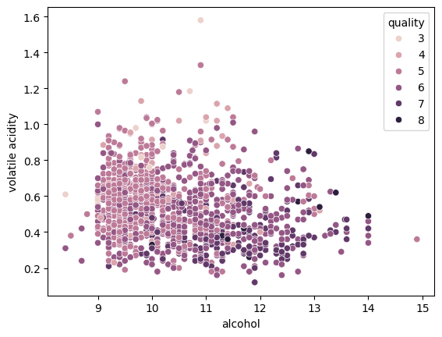

Conclusion:
This Exploratory Data Analysis of the red wine quality dataset provides valuable insights into the factors influencing wine quality. The analysis shows that wine quality does not depend on a single feature, but rather on a combination of physicochemical properties. Alcohol content and volatile acidity play the most significant roles, while other features contribute moderately.
Therefore, wine quality is a multifactorial outcome influenced by the combined effect of physicochemical properties rather than a single dominant factor.

